D Flip-Flop Simulations Partner -> Sam A. answers for D Flip-Flop Simulations lab

round all your times to the nearest picosecond
1. D Flip-Flop clk-to-q Time | 3. D Flip-Flop Hold Time
Baseline CLK-TO-Q Times  Simulation 1 data high CLK-to-Q = 569 ps  Simulation 1 data low CLK-to-Q = 504 ps | Simulation 3 data high hold time = -50 ps  CLK-to-Q delay = 577 ps  Simulation 3 data low hold time = -70 ps  CLK-to-Q delay = 510 ps
2. D Flip-Flop Setup Time | 4. D Flip-Flop Data Requirements
Simulation 2 data high setup = 220 ps  CLK-to-Q delay = 578 ps  Simulation 2 data low setup = 260 ps  CLK-to-Q = 513 ps | Simulation 4 data high 11.73 ns to 12.1 ns  CLK-to-Q delay = 570 ps  Simulation 4 data low 19.79 ns to 20.05 ns  CLK-to-Q delay = 513 ps
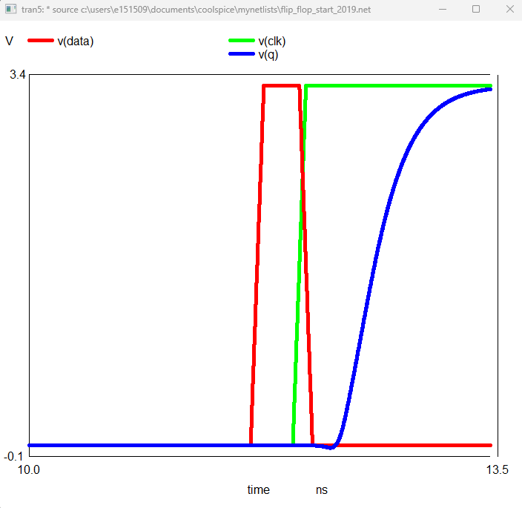 | 